Birdwatching at

Madeira
1-15 September 2003

By Klas Rådberg and Stefan Magnusson

Participants
1-8/9: Klas Rådberg and Stefan Magnusson
9-15/9: Stefan Magnusson

Introduction
Though we both are birdwatchers from Lund, in the southern part of Sweden, we met by a coincidence at the airport in Funchal. As soon as we started to watch seabirds together it became obvious that it was a big advantage to be more than one person in this aspect. The distance to the birds and the light conditions created many impressions to discuss and it was also very valuable to share the joy of spectacular and overwhelming observations of birds you have dreamt of.

We stayed at different hotels in Funchal but Klas had hired a car for his week on the island. It took approximately one hour to drive from Funchal to Porto Moniz via the tunnel system depending on the traffic intensity. On Friday 5 September we joined a trip to Desertas with ‘Ventura do Mar’. A rather strong wind came from NE and the sea was quite rough. As we left the nearness to Madeira we had a Monk Seal around fifty meters from the boat and Stefan managed to photograph the head of the animal. It was the first time Filipe, the captain, had seen a Monk Seal between Madeira and Desertas. The strong wind also made the seabirds active and we had twenty-five observations of Fea’s/Zino’s Petrel from the boat (some English birders had forty observations from another position on the boat). We can highly recommend a trip with ‘Ventura do Mar’ and Filipe and his crew are very pleasant and professional.

The purpose of the present trip report is to share our observations, impressions and feelings with other seabird watching freaks. For more detailed Madeiran trip reports concerning all kinds of precious information we especially recommend Holmström 2002 and Hansson & Hansson 2003.

Ponta da Cruz
Situated in the western outskirts of Funchal, Ponta da Cruz is a good spot for the eager new arriver or the family traveller with limited time for birdwatching. Even if a proportionally high amount (in relation to the time spent) of Fea’s/Zino’s petrels and Bulwer’s petrels were seen from this spot, the birds we saw probably belonged to the breeding species of Madeira and the surrounding islands. In addition, birds were seen far from shore (a 60X Zoom under weak wind conditions is recommended). If you want to get the ultimate out of the sea birding, drive the extra hour to Porto Moniz, which offers closer views, larger amount of seabirds but above all, the true migraters.
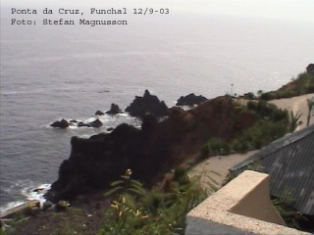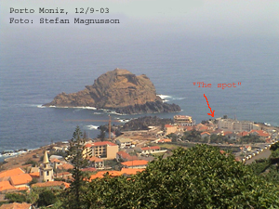

Porto Moniz

In ‘Roadrunner’ 4:1998, Klaus Malling Olsen states that “Proto Moniz has to be one of the best land spots for seabird watching in the Western Palaearctic” and after our days at this location we have to agree. The seabird watching from Porto Moniz is just excellent! The place offers high numbers, good views, an exciting mixture of species and the opportunity to a unique practice in seabird identification. However, we had some problems in finding out where the best watch point was situated. Finally we choose a place just east of the ‘Ilheu Mole’. The light conditions from this spot were best during the afternoon, but when it was cloudy the light was good from here before noon as well. The seabirds we identified at Porto Moniz are shown below in table 1.

Table 1. Counted seabirds at Porto Moniz.

Date | 3/9 | 4/9 | 6/9 | 7/9 | 12/9 | Total
Wind | S, < 5 m/s | N, 6-8 m/s | NE, 6-8 m/s | NE, 10-12 m/s | E, 6-8 m/s
Observer | Klas & Stefan | Klas | Klas & Stefan | Klas & Stefan | Stefan
Time span | 7:15-12, 15:30-20 | 7:45-12, 14:15-18 | 8:10-12:20, 13:30-20 | 8:10-19:00 | 13.00-14.00
Fea’s/Zino’s Petrel** | 1 | - | 2 | - | - | 3
Bulwer’s Petrel** | 62 | 3 | 49 | 19 | 10 | 143
Cory’s Shearwater* | 600 | 390 | 1000 | 700 | 40 | 2730
Great Shearwater | - | - | 911 | 4438 | - | 5349
Sooty Shearwater | - | - | 2 | - | - | 2
Manx Shearwater | 266 | 215 | 513 | 263 | 11 | 1268
Little Shearwater | 1 | - | - | - | - | 1
Great Skua | 3 | - | 2 | 1 | - | 6
Pomarine Skua | - | - | 7 | - | - | 7
Arctic Skua | 3 | - | 1 | - | - | 4

*Cory’s Shearwater: In contrast to the other counted and assumed migrating species, the numbers of this bird were roughly estimated. Big flocks of Cory’s Shearwaters flew back and forth outside the cliffs and it was impossible to contempt if it was migrating birds or not.

**Fea’s/Zino’s/Bulwer’s Petrels: As these birds move back and forth to breeding areas on daily basis, birds were seen flying both W and E from Porto Moniz (in contrast to the true migraters only moving W). This together with their erratic flight pattern (at times interrupting their path and turning the opposite direction) sometimes made them hard to count (“is this the same bird or a new one?”). One example is the 2 Fea’s/Zino’s seen on 6/9: The observations concerned one W-moving bird and one E-moving bird but with a three hour span between the observations. We decided to count all seen birds, if it was not obviously the same bird.
A few words must be said about the amazing days we had at Porto Moniz (6+7/9):
…

“On morning 6/9 the car left for Porto Moniz for the third time. Arriving a bit later than earlier days we still felt we had time to grab a quick cup of coffee at a local restaurant in Porto Moniz. As all the other days (and having in mind that the return to Sweden was coming closer) we wondered if any Great Shearwaters would “finally” show up this day. We made jokes on how we would “shout out” the first Greater if it showed up. After half an hour of birding this morning Stefan suddenly got a glimpse of a large shearwater extremely close with white cheeks and neck collar, brown “hat” and a white “tail band” with fast flight very close to round “the Mole”… “- Great shearwater! Close to the edge!!!”. In a few seconds the bird was behind the Mole and telescopes were set to the west edge of the Mole in hope that the shearwater would show up on the other side.

Two CORY’S finally did!!!

A bit of brain-collapse and Klas tearing his hair in having missed the bird. Stefan weighing the opportunity of actually having misidentified the Greater for a Cory’s or the shearwater managing to pass in another line (further out) after rounding the Mole (with current knowledge the shearwaters needed substantial TIME to show up on the other side of the large Mole. In addition, some birds never did…). Nothing seemed to fit! After another quarter (still discussing that it MUST have been a Great judged by the characters seen…) Klas suddenly starts making strange sounds immediately followed by a “wobbly” roar. “G-g-gGGREAAAT SHEEAAARWATER!!! MANY BIRDS!!!” Soon I get a loosely organized flock of large Shearwaters in my scope and yes it sure was a “flock” of Great Shearwaters!!! What an amazing sight! The minutes after were full of joyful shouts and grown up men behaving like ten-year-old boys or football players having scored a world-cup winning goal. With some distance we had to wonder what went through the minds of the 5 workers of the construction-site who looked at us through a net fence. We surely must have behaved like “two monkeys on a cliff”.”

…

This day 911 Great Shearwaters were counted. Adding to that two flocks of (3 + 4) adult pale morph Pomarine Skuas with “clubs”, 2 Sooty Shearwaters (one very close), 2 (young) Great Skuas, 2 observations of Fea’s/Zino’s Petrels, 49 Bulwer’s Petrels, 1 Arctic Skua, 513 Manx Shearwaters and about 1000 Cory’s Shearwaters. Most birds were seen close and the conditions for seawatching (grey sky and grey sea giving neutral colours) were optimal.

The day after (7/9), with 4438 Great Shearwaters, was an even more amazing day considering numbers. To us however due to lack of other species, this day will not be graded as good as the day before. Still it was an amazing sight to see the hordes of Great Shearwaters flying westwards. Birds were counted using an index (the day before ALL birds were counted). One of us counted the number of Great Shearwaters passing the Mole in 10 minutes and then this index was used for the next 20 minutes (this meant one count per half hour). As soon as we suspected a change in the migratory intensity, we counted for another 10 minutes. The flow of birds was surprisingly consistent all day, but of course some drops/peaks were noted. Over the whole day the index stayed at about 75 birds per 10 minutes but at noon the migration decreased a bit (about 40 birds per 10 minutes). Around 4 pm the highest index of the day was reached with 133 Great Shearwaters passing in 10 minutes.

Only clearly identified Great Shearwaters (by plumage characters) were counted. We guess that about 20% more birds could have been obtained if we would have counted “likely Great Shearwaters” a bit further out from the shore. To be honest: the identity compared to Cory’s Shearwater was quite easy after a while because of the unique practice. We missed 45 minutes in the morning (+300 birds?) and 1.5 hour in the evening (+700 birds?), so the total number of passing Great Shearwaters probably were around 5500 at Porto Moniz the actual day.
Bulwer’s petrel… Cory’s shearwater…
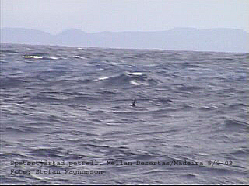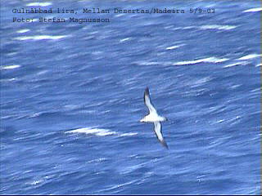

Species List (English, scientific and Swedish names)

Fea’s/Zino’s Petrel – Pterodroma feae/madiera – Atlant-/Madeirapetrell
31 in total – 1 Ponta da Cruz 1/9, 2 Ponta da Cruz 2/9, 1 Porto Moniz 3/9, 25 from ‘Ventura do Mar’ between Madeira and Desertas 5/9, 2 Porto Moniz 6/9.

Fea’s Petrel – Pterodroma feae – Atlantpetrell
1 came just a few meters from ‘Ventura do Mar’ and showed the features for Fea’s.

Bulwer’s Petrel – Bulweria bulwerii – Spetsstjärtad petrell
234 in total – 1 Ponta da Cruz 1/9, 66 Ponta da Cruz 2/9, 62 Porto Moniz 3/9, 3 Porto Moniz 4/9, 24 from ‘Ventura do Mar’ between Madeira and Desertas 5/9 (some quick and close observations), 49 Porto Moniz 6/9, 19 Porto Moniz 7/9, 10 Porto Moniz 12/9.

Cory’s Shearwater – Calonectris diomedea borealis – Gulnäbbad lira
3930 in total – seen everywhere over the sea. Their strange calls were heard during night-time in mountain areas at Madeira.

Great Shearwater – Puffinus gravis – Större lira
5349 in total – 911 Porto Moniz 6/9, 4438 Porto Moniz 7/9.

Sooty Shearwater – Puffinus griseus – Grålira
2 in total – 2 Porto Moniz 6/9. One came very close.

Manx Shearwater – Puffinus puffinus – Mindre lira
1271 in total – 266 Porto Moniz 3/9, 215 (28 in one single flock!) Porto Moniz 4/9, 3 ‘Ventura do Mar’ 5/9, 513 Porto Moniz 6/9, 263 Porto Moniz 7/9, 10 Porto Moniz 12/9.

Little Shearwater – Puffinus assimilis baroli – Dvärglira
1 in total – 1 Porto Moniz 3/9. Compared to older trip reports, some Little Shearwaters might have been missed. However, much attention was put on close flying small shearwaters but all birds were after detailed views identified as Manx’s Shearwaters and this must be considered as the only disappointment at the trip. The only identified Little Shearwater was obviously another species in both flight and shape compared to Manx’s Shearwaters.

Little Egret – Egretta garzetta – Silkeshäger
7 in total – 3 Machico 2/9, 1 Porto Moniz 4/9, 2 Funchal harbour 5/9 (1 seen 13/9 + 14/9), 1 Ribeira Brava 12/9.

Grey Heron – Ardea cinerea – Gråhäger
2-3 in total – 1 Machico 2/9, 1 Funchal 4/9, 1 Funchal 8/9.

Sparrowhawk – Accipiter nisus granti – Sparvhök
A few observations at different places.

Buzzard – Buteo buteo – Ormvråk
Fairly common.

Kestrel – Falco tinnunculus canariensis – Tornfalk
Common, seen every day.

Sanderling – Calidris alba – Sandlöpare
2 in total – Machico 2/9.

Ringed Plover – Charadrius hiaticula – Större Strandpipare
1 in total – 1 Funchal 14/9

Whimbrel – Numenius phaeopus – Småspov
43 in total – 1 Ponta da Cruz 2/9, 7 Porto Moniz 3/9, 3 Porto Moniz 4/9, 32 Porto Moniz 6/9.

Turnstone – Arenaria interpres – Roskarl
Common, seen every day along the coast.

Great Skua – Stercorarius skua – Storlabb
6 (young) in total – 3 Porto Moniz 3/9, 2 Porto Moniz 6/9, 1 Porto Moniz 7/9.

Pomarine Skua – Stercorarius pomarinus – Bredstjärtad labb
7 in total – 4 + 3 ad Porto Moniz 6/9.

Arctic Skua – Stercorarius parasiticus –Labb
4 in total – 3 (1 pale ad, 2 juv) Porto Moniz 3/9, 1 juv Porto Moniz 6/9.

Atlantic Herring Gull – Larus michahellis atlantis – ”Medelhavstrut”
Common, seen every day along the coast.

Lesser Black-backed Gull – Larus fuscus graellsii – Silltrut
2 in total – 2 Porto Moniz 3/9.

Common Tern – Sterna hirundo – Fisktärna
Common, seen every day along the coast.

Feral Pigeon – Columba livia – Stadsduva
Common in different colour forms.

Long-toed Pigeon – Columba trocaz – Madeiraduva
8 in total – 5 around Ribeiro Frio and Balcoes 2/9, 3 Caldeirao Verde 11/9, 2 (road to) Balcoes 11/9. Birds were heard playing.

Barn Owl – Tyto alba alba – Tornuggla
4 in total – 2 ad + 2 juv Garajau 4/9, 1 ad + 2 juv Garajau 7/9.

Plain Swift – Apus unicolor – Enfärgad seglare
Common everywhere.

Grey Wagtail – Motacilla cinerea schmitzi – Forsärla
Common, seen every day and especially along the coast. Even in mid Funchal.

Berthelot’s Pipit – Anthus berthelotii madeirensis – Kanariepiplärka
5 in total – 5 Desertas Grande 5/9.

Robin – Erithacus rubecula – Rödhake
Heard almost every day.

Blackbird – Turdus merula cabrerae – Koltrast
Heard and seen every day.

Blackcap – Sylvia atricapilla heineken – Svarthätta
Heard and seen at different locations. Birds were checked but no “black males” were seen.

Madeira Firecrest (juvenile)… Chaffinch (Male)…
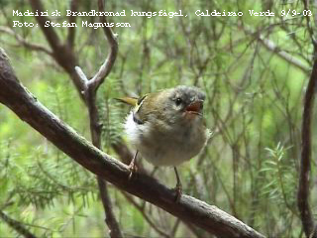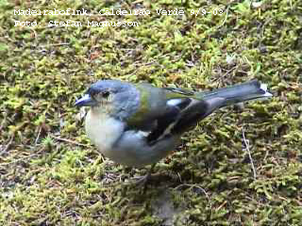

Madeira Firecrest – Regulus ignicapillus madeirensis – Brandkronad kungsfågel
Common in the mountains. Mostly juveniles, but a couple of adults were also observed. Young birds were very easy to drive closer by making “tit-sounds”. One landed for a second on Stefans head!

Chaffinch – Fringilla coelebs madeirensis – Bofink
Common in the mountains. Looked (both sexes) and sounded different compared to our Swedish Chaffinch.

Canary – Serinus canaria – Kanariesiska
Common, seen and heard every day.

Goldfinch – Carduelis carduelis parva – Steglits
One big flock was observed in Funchal 8/9. Two birds were seen in Santana 11/9.

Berthelot’s Pipit… Canary…
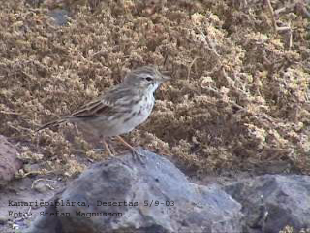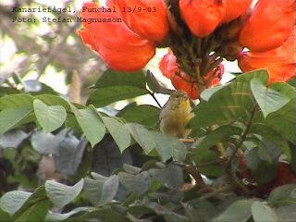

Marine Mammals
Monk Seal (Monachus monachus)
One was observed between Madeira and Desertas around 50 meters from the boat ‘Ventura do Mar 5/9.

Desertas (Deserta Grande, landing spot)… Monk seal…
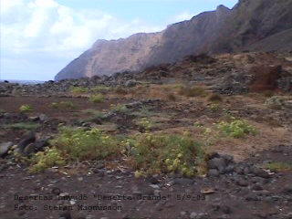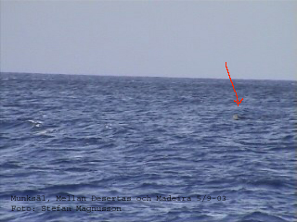

Spotted Dolphin (Stenella frontalis)
A group of 6-10 individuals was observed between Madeira and Desertas right by the boat ‘Ventura do Mar 5/9.

Bottle-nosed Dolphin (Tursiops truncatus)
A group of fifteen individuals was seen off Ponta da Cruz 1/9.

Unidentified Whale (…)
A larger unidentified whale was seen blowing two times before diving (without showing the tail-fin) at Ponta da Cruz 1/9. According to Madeiran shippers many Fin-whales had been seen in the waters at this time.

Acknowledgements
We are grateful for the useful information provided by Niklas Holmström and Göran Hansson before our trip and for all other information in various trip reports found on the net.

Written by:
Klas Rådberg, Pärlemorvägen 4, 226 51 Lund, SWEDEN,
Klas.Radberg@astrazeneca.com

Stefan Magnusson, Råbygatan 3, 223 61 Lund, SWEDEN, Stefan.Magnusson@mbox323.swipnet.se

